1. Problem Understanding

Description of the Problem

Contemporary clinical practice is transitioning from reactive symptom management to preventative risk mitigation for chronic metabolic conditions. This study aims to architect a robust classification framework capable of identifying high-risk individuals through non-invasive physiological metrics. By evaluating the efficacy of traditional Logistic Regression against Deep Learning Neural Networks, the research seeks to identify the optimal architecture for managing data stochasticity and noise in features such as Body Mass Index, age, and vascular pressure to deliver high-fidelity binary risk assessments.

Importance of Predicting Diabetes Risk

The implementation of predictive analytics in diabetes care is vital for optimizing public health outcomes through:
- Proactive Intervention: Enabling early-stage behavioral modifications to avert chronic disease progression.
- Operational Efficiency: Streamlining resource allocation by identifying high-priority cohorts to alleviate systemic pressure.
- Economic Sustainability: Minimizing long-term healthcare expenditures by preventing expensive secondary pathologies.
- Patient Outcome Optimization: Elevating standards of care through data-driven preventative measures.
- Strategic Public Health Policy: Supporting targeted screening initiatives and large-scale awareness campaigns.
2. Data Exploration Insights

Key Observations from the Dataset
An analysis of the cohort comprising 6,000 subjects revealed the following statistical properties:
- Data Integrity: The dataset is characterized by complete feature density with no null values, ensuring model consistency.
- Class Skew: Positive cases constitute only 9.03% of the population, necessitating specialized handling of minority class representation.
- Age Demographic: The sample spans 18 to 84 years, with a central tendency at 51 years.
- Biometric Indicators: Mean BMI (26.0) and Blood Pressure (134.2 mmHg) metrics indicate a cohort trending toward pre-hypertensive and overweight categories.

Analysis of the Distributions
1. Demographic Correlation: Age
Comparative visualization of diabetes status relative to age reveals that while negative cases are uniformly distributed, positive diagnoses are disproportionately clustered within the 60 – 80 year range, validating age as a significant discriminatory feature.
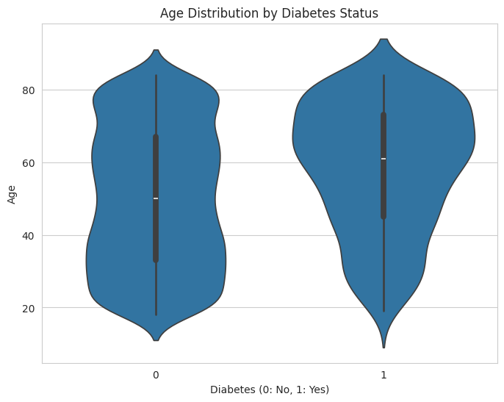
2. Physiological Correlation: BMI
BMI density plots demonstrate a clear divergence between the two groups. Specifically, the probability of diagnosis accelerates significantly as BMI exceeds the 30.0 kg/m² threshold, marking it as a critical indicator for clinical classification.
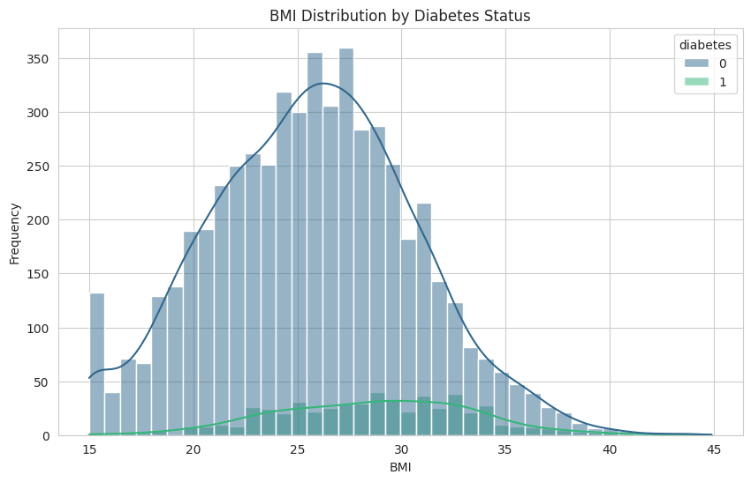
3. Behavioral Correlation: Physical Activity
Analysis of weekly exercise suggests a negative correlation with diagnosis. Patients identified as Diabetes: 1 exhibit a markedly higher density in sedentary behavior compared to the non-diabetic population, underscoring activity level as a predictive behavioral metric.
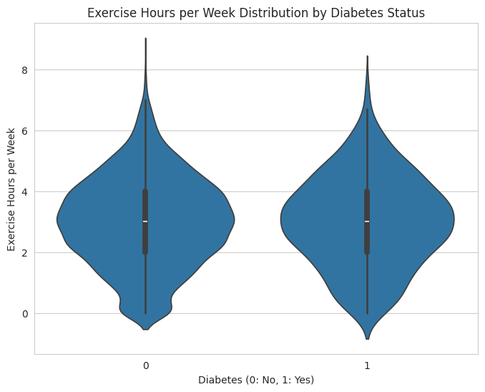

Important Features Influencing Prediction
Statistical evaluation identifies the following features as having the highest variance and impact on model output:
- BMI: The primary statistical driver (correlation 0.17), showing peak diabetic prevalence between 30 and 35.
- Blood Pressure: A key secondary metric (correlation 0.15) linked to metabolic dysregulation.
- Age: A significant demographic factor (correlation 0.12) concentrated in the senior population.

3. Model Implementation

Explanation of the Machine Learning Model
Logistic Regression was deployed as the baseline classifier. This linear model calculates class probabilities through a weighted aggregation of input features, providing a transparent and interpretable understanding of how specific health attributes contribute to the overall risk profile.

Explanation of the Neural Network Architecture
The Deep Learning architecture utilizes a multi-layer Sequential Artificial Neural Network (ANN) optimized for binary classification tasks.
- Input Configuration: Processes five normalized health features, including BMI and vascular pressure.
- Hidden Layers: Consists of two fully connected (Dense) layers with 16 and 8 neurons respectively. The ReLU activation function is used in both to introduce non-linearity.
- Output Layer: A single neuron with a Sigmoid activation function, which outputs the final probability score between 0 and 1.

4. Model Evaluation

Comparative Performance Assessment

Baseline Performance: Logistic Regression
The linear model demonstrated an accuracy of 65%. Its performance reflects a broader generalization attempt to account for the underrepresented positive class.
Coefficient Analysis:
Feature significance was quantified as follows:
- BMI (0.524): Primary positive correlate.
- Age (0.337): Secondary positive correlate.
- Blood Pressure (0.273): Tertiary physiological driver.
- Tobacco Status (-0.176): Indicates a marginal inverse relationship in this dataset.
- Exercise (0.033): Nominal impact on prediction.

Deep Learning Model (ANN)
The ANN reached a high accuracy of 90.5% with a test loss of 0.3473. However, localized performance on the minority class remains deficient.

Analytical Visualizations

Statistical Classification Metrics

Classification Report for ANN:
precision recall f1-score support

0 0.91 0.99 0.95 1092
1 0.29 0.04 0.07 108

accuracy 0.91 1200
macro avg 0.60 0.51 0.51 1200
weighted avg 0.86 0.91 0.87 1200

Confusion Matrix Visualization

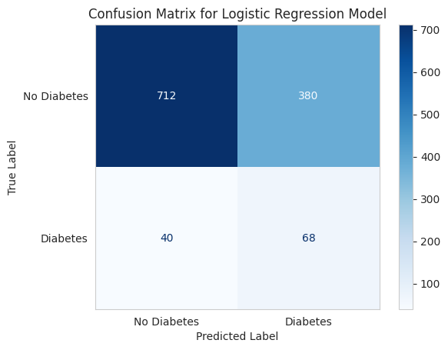

Neural Network Performance Metrics

Classification Report for ANN:
precision recall f1-score support

0 0.91 0.99 0.95 1092
1 0.29 0.04 0.07 108

accuracy 0.91 1200
macro avg 0.60 0.51 0.51 1200
weighted avg 0.86 0.91 0.87 1200

ANN Confusion Matrix:

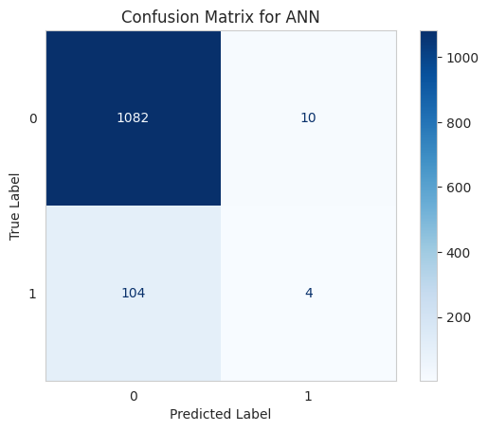

5. Comparative Analysis

Architectural Comparison
The comparison reveals a significant tension between the complexity of the algorithm and its practical value in a medical setting:
- Precision vs. Detection: Although the neural network achieved a higher overall accuracy of 90.5%, this number is misleading as it fails to capture actual positive cases. In contrast, Logistic Regression, with 65% accuracy, provides much clearer insights through its direct feature weighting.
- Clarity of Logic: Logistic Regression identifies BMI (0.524) and Age (0.337) as the main predictors, while the neural network's internal processing makes its reasoning difficult to interpret.
- System Balance: Simple linear models offer a steady starting point, whereas complex neural networks can easily skew toward the most frequent data points if not carefully tuned.

Reasons for Accuracy Differences
This performance gap stems largely from the unbalanced nature of the data and the different ways each model processes information:
- Neural Network Skew: The 90.5% success rate happens because the model prioritizes identifying non-diabetic individuals (Recall: 0.99) while ignoring those with the condition (Recall: 0.04).
- Regression Balance: The 65% accuracy represents a more even-handed approach that avoids the heavy bias toward the majority group seen in the neural network.

Recommendations for Real-World Use
Because missing a diagnosis carries high risks, the following improvements are suggested:
- Neural Network Limitations: Any model that overlooks 96% of people at risk is not suitable for medical screening.
- Prioritizing Sensitivity: Future versions must focus on improving the detection rate of positive cases to ensure patient safety.
- Next Steps: Logistic Regression is currently the better option because it is easy to understand. For full use, advanced data balancing and weighting are needed to reach medical safety standards.

